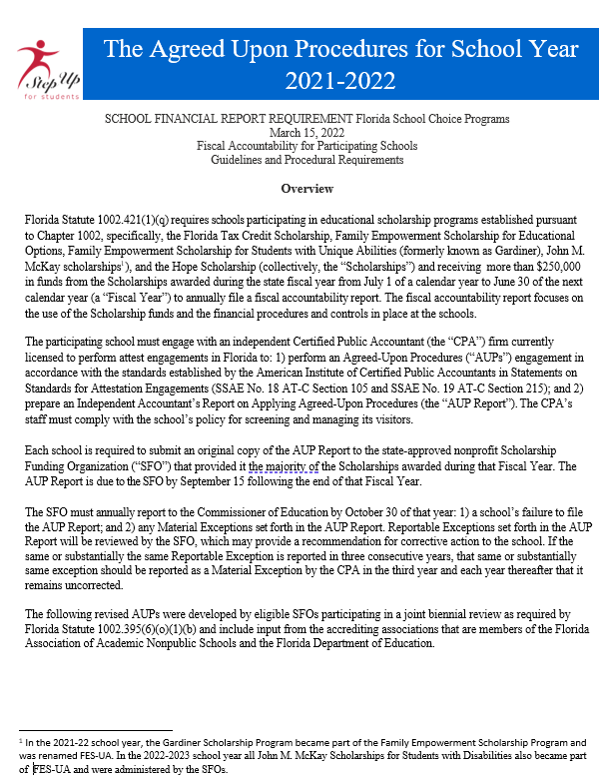
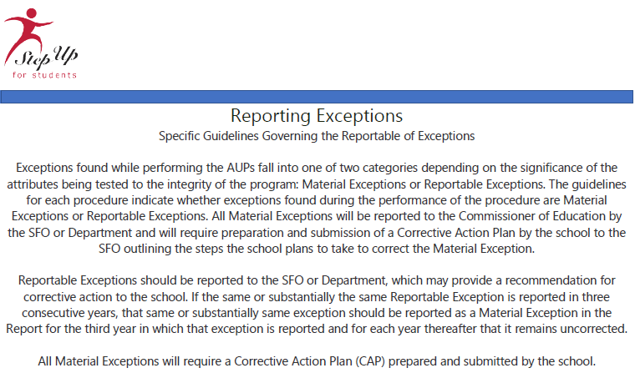

Independent Accountant's Report
on Applying Agreed-Upon Procedures
for 2021-2022 School Year

To Step Up For Students Scholarship Funding Organization:

We have performed the procedures enumerated below, which were agreed to by Step Up For Students Scholarship Funding Organization, solely to assist the specified parties in evaluating (Name of School’s) (“the School”) compliance with the requirements of Florida Statute 1002.421(1)(q) during the school year ended June 30, 2022. The School’s management is responsible for compliance with those requirements.

The School has agreed to and acknowledged that the procedures performed are appropriate to meet the intended purpose of, solely assisting the specific parties in evaluating the School’s compliance with the requirements of Florida Statue 1002.421(1)(q) during the school year ended June 30, 2022. This report may not be suitable for any other purpose. The procedures performed may not address all items of interest to a user of this report and may not meet the needs of all users of this report and as such, users are responsible for determining whether the procedures performed are appropriate for their purposes.

We were engaged by the school to perform this agreed-upon procedures engagement and conduct our engagement in accordance with attestation standards established by the American Institute of Certified Public Accountants. We were not engaged to, and did not, conduct an examination or review, the objective of which would be the expression of an opinion or conclusion, respectively, on compliance with the requirements of Florida Statute 1002.421(1)(q) during the school year ended June 30,2022. Accordingly, we do not express such an opinion or conclusion. Had we performed additional procedures; other matters might have come to our attention that would have been reported to you.

We are required to be independent of the School and to meet our ethical responsibilities, in accordance with the relevant ethical requirements related to our agreed upon procedures engagement.

This report is intended solely for the information and use of the Step Up for Students, Florida Department of Education and the School’s management, is not intended to be, and should not be used by anyone other than these specific parties.

CPA's Name:

CPA Firm Name:

CPA's Email Address:

CPA's phone number:

School Name:

DOE Number:
Enter the 4-digit DOE number assigned to the school.

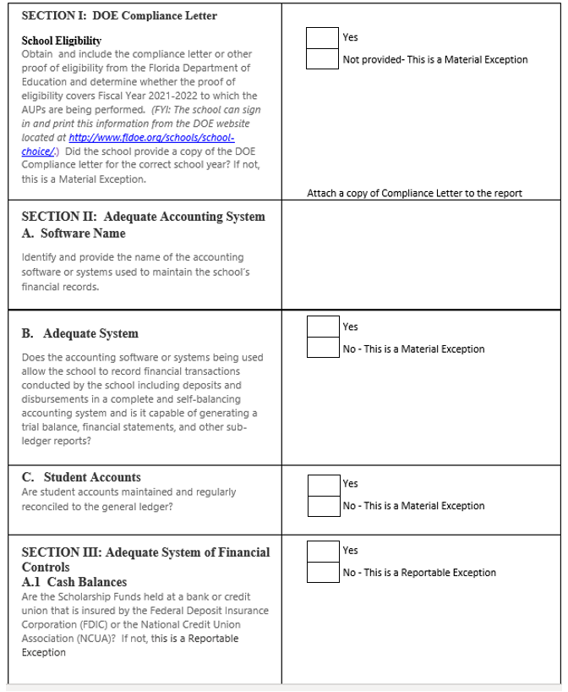

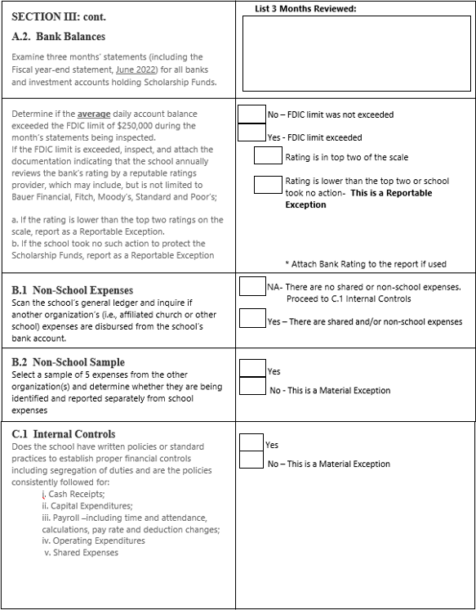

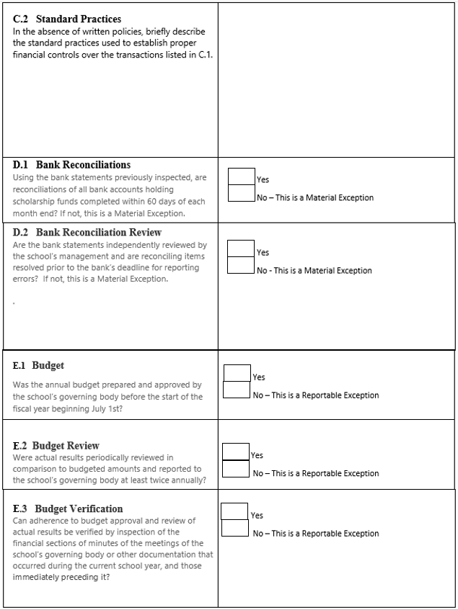

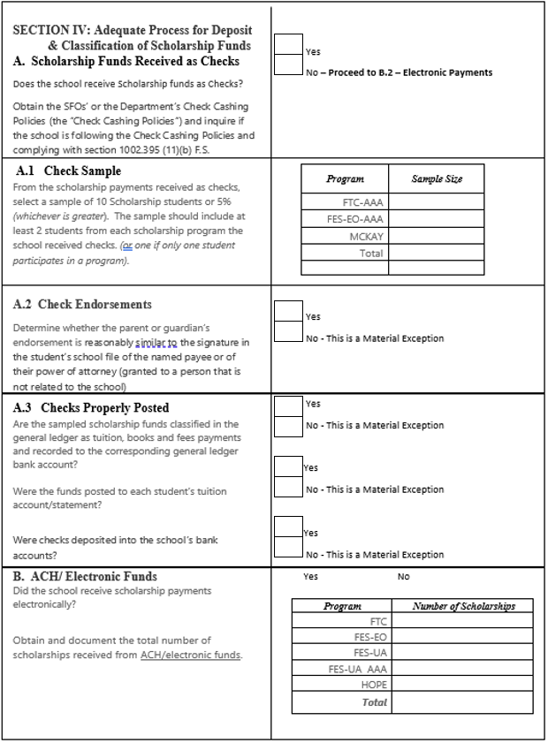

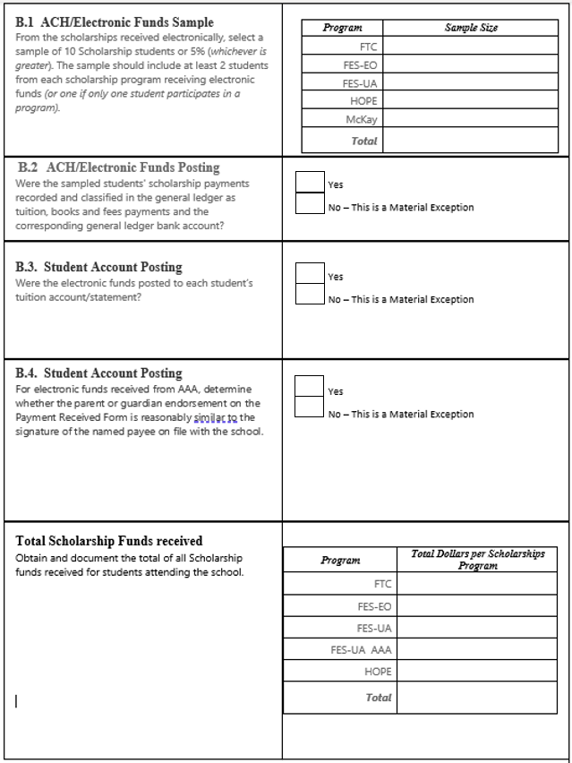

N/A – There are no AAA electronic payments

AAA _Payment Received Form

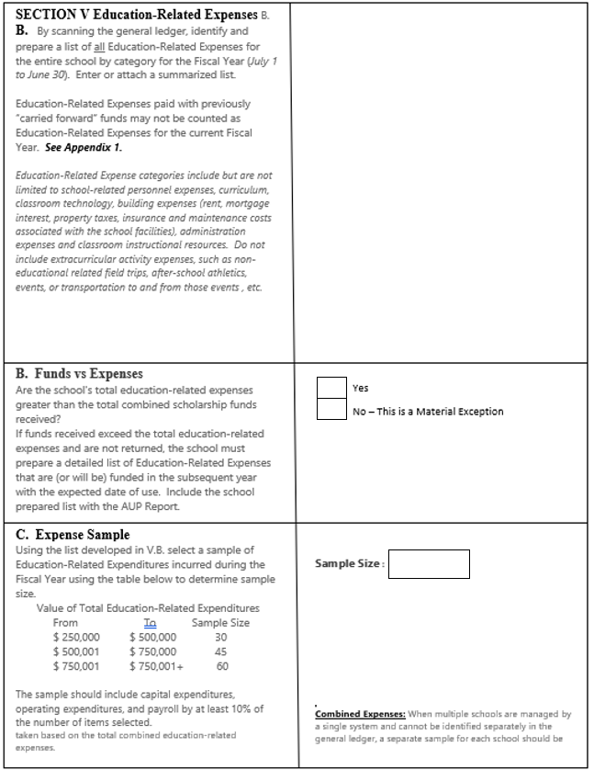

_{V.A.}

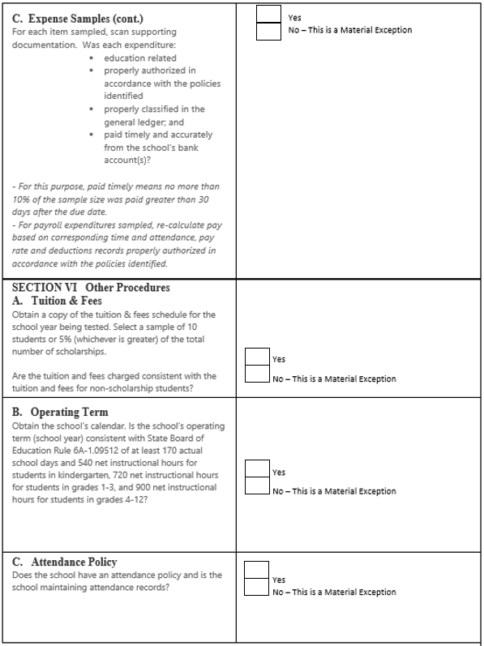

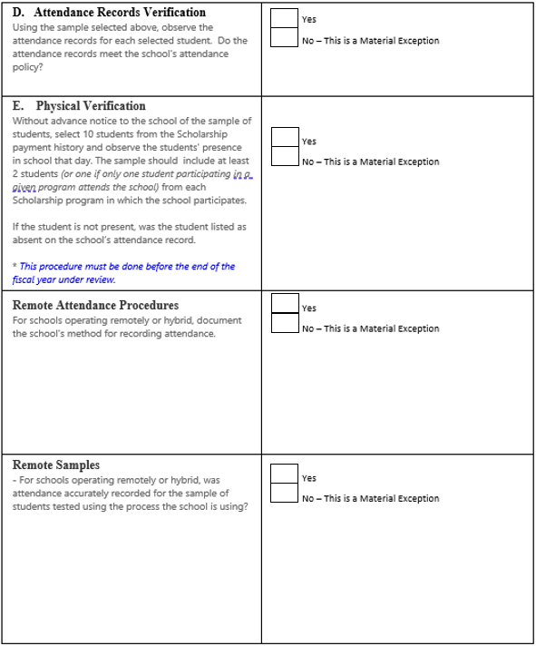

N/A

N/A

